**LAYOUT FILE: resources/views/Components/Layout.blade.php**

* The layout.blade.php file serves as a reusable template that establishes a uniform framework for a number of web pages, including our project's home, about, and contact pages. Common components like the header, footer, and navigation can be kept while allowing specific pages to use @yield to add their own content.

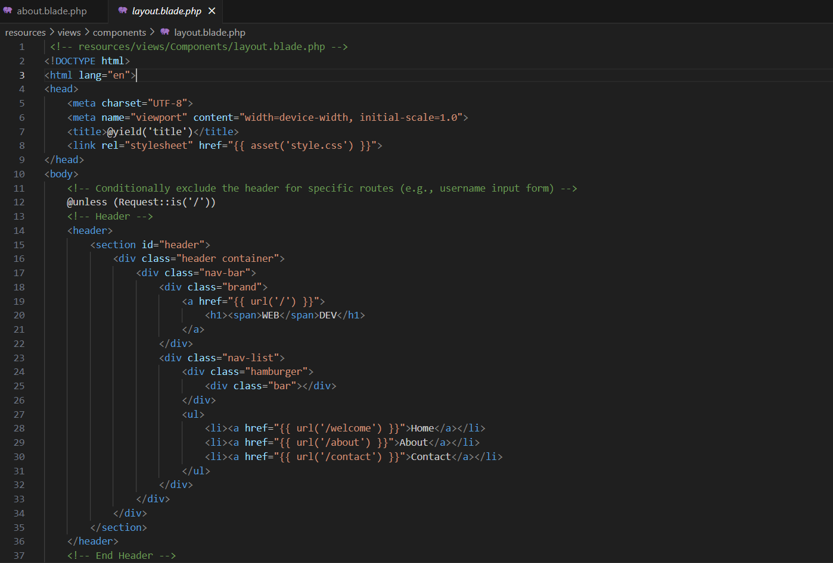

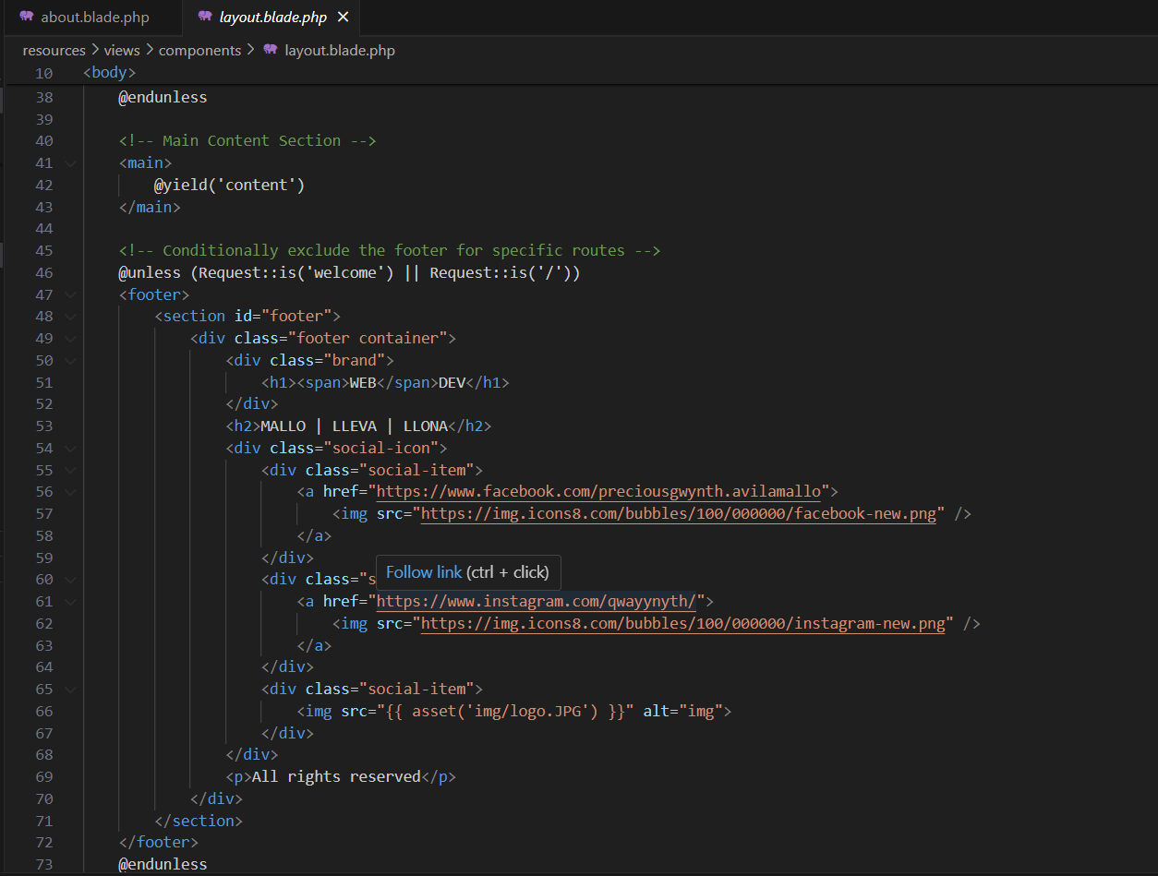

**VIEWS**: **resources/views/about.blade.php**

* The view in the `about.blade.php` file can inherit the structure from `layout.blade.php`, which comprises common elements like the header and footer, due to the `@extends('Components.Layout')` directive. While the `@section('content')` describes the special content for the about page, it replaces the `@yield{, the `@section('title', 'About-My Website')} inserts the page-specific title.

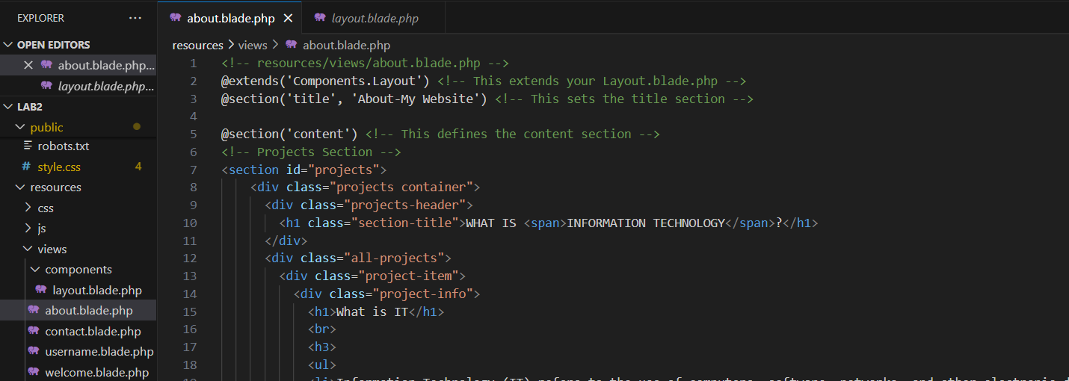

**VIEWS**: **resources/views/contact.blade.php**

* The layout in the file `contact.blade.php} extends using {@extends('Components.Layout')}, which allows the view to recycle the `layout.blade.php` structure. The title for the contact page is set precisely by the `@section('title', 'Contact-My Website')}. The unique contact form and contact details are then inserted into the layout's `@yield('content')} section by the `@section('content')` block. This method permits the contact page's content to be modified while maintaining a consistent layout structure.

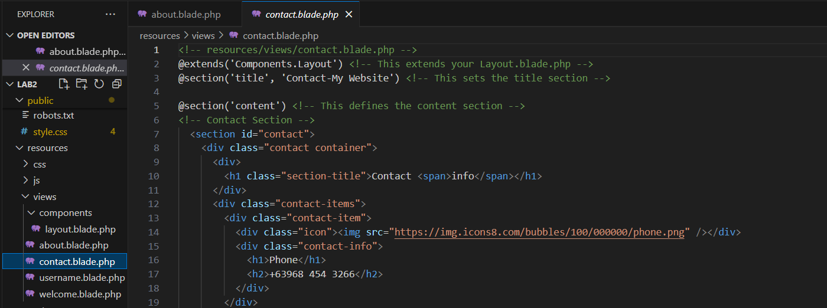

**VIEWS**: **resources/views/username.blade.php**

* The layout in the file `username.blade.php} is extended using the structure of {@extends('Components.Layout')} comes from `layout.blade.php}. The particular title of this page is set by the `@section('title', 'Username - My Website')}. The content for the username input form is defined in the {@section('content')} block and is inserted into the `@yield('content')} section of the layout. When specific routes are requested, the header and footer are excluded by the `@unless` directive in `layout.blade.php}. The header and footer of this `username.blade.php} view are conditionally excluded based on the `Request::is('/')} condition in the layout because the form action goes to `/welcome}. This guarantees that the page with the username form will look cleaner without the header and footer.

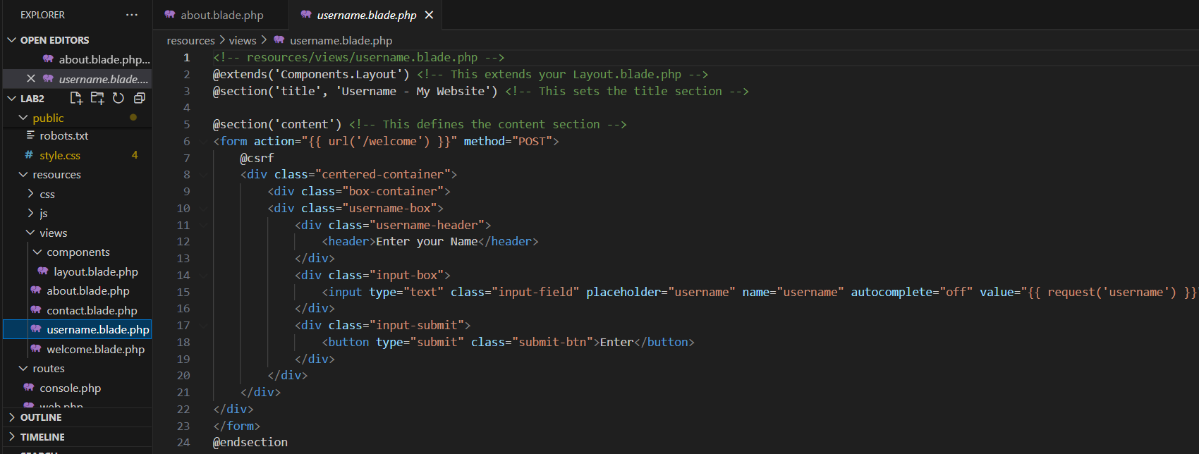

**VIEWS**: **resources/views/welcome.blade.php**

* The layout in the `welcome.blade.php} file is extends the structure of {@extends('Components.Layout')} is inherited from `layout.blade.php}. The content is injected into the layout's `@yield('content')` section, and the specific page title is defined by the `@section('title', 'Welcome - My Website')}. The `@unless` directive in the layout file (`layout.blade.php}) is used to selectively exclude the footer on specific routes, such as `/welcome}.

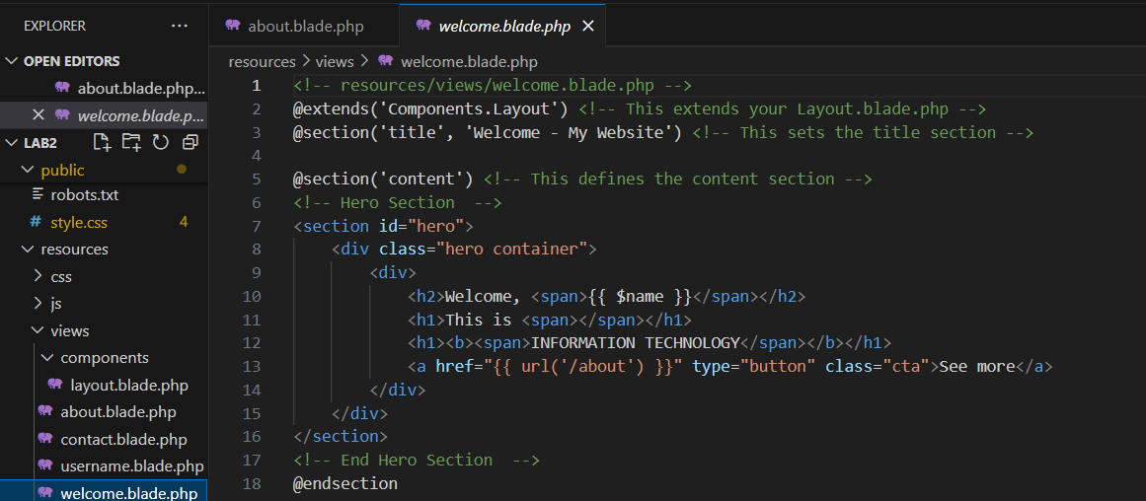

**ROUTE:**

* The routing setup of this website manages the relationships between various URLs and particular views or actions. Users see a form where they can input their login when they visit the root URL ({/}). They receive a personalized greeting based on the username they entered on the `/welcome} page after submitting the form, which is processed by the app. Furthermore, routes pointing to static sites such as `/about} and `/contact} connect visitors to the relevant views. This set up guarantees that every URL points to the appropriate feature or content, resulting in a smooth and user-friendly navigation.

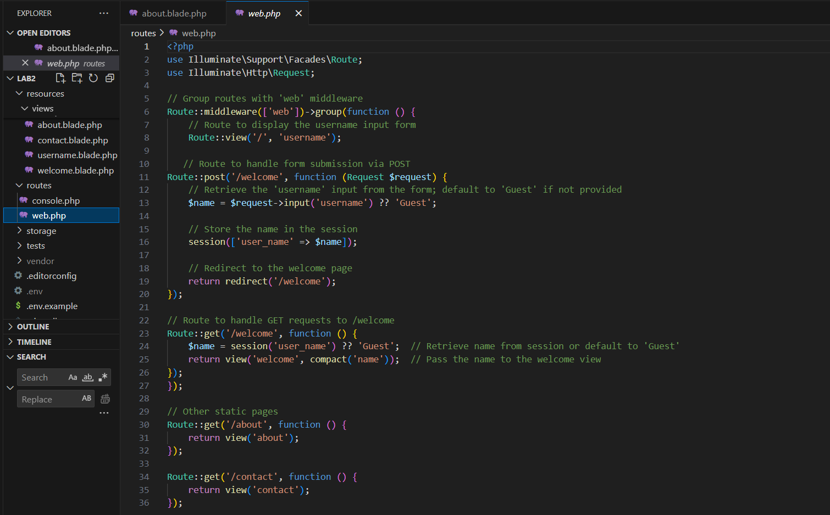

**CHALLENGE ENCOUNTERED:**

* One of the challenges that we encountered was figuring out how to make the layout.blade.php file larger. All of the layouts, including the header and footer, were applied to views that weren't in need of them when we extended it to other views. We used the @unless directive to conditionally exclude specified portions from particular views in order to overcome this issue.

**DIFFERENCE BETWEEN {{$slot}} and @yield:**

* {{$slot}} is used within components to define default content that can be replaced when the component is used, making it ideal for reusable blocks of code. On the other hand, @yield is used in layouts to define a placeholder where content from child views will be injected. Essentially, {{$slot}} is for components, while @yield is for layouts and templates.